A Guide to the School Transportation

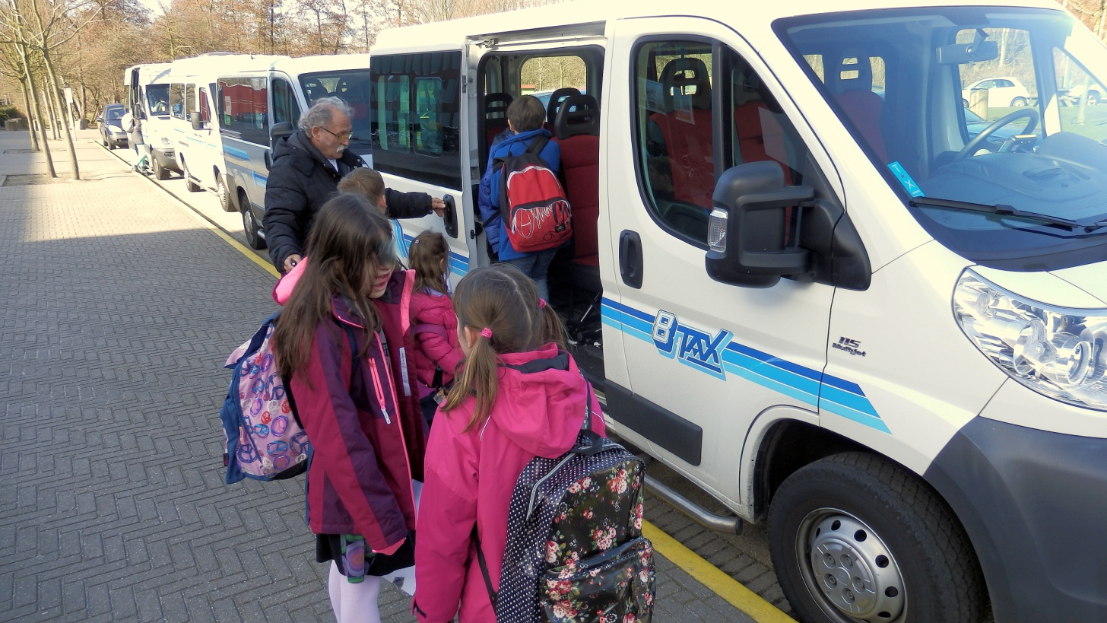

Standard Terms
And Conditions
2018-2019
Definition of Service

The International School of The Hague works together with a certified community taxi Company called Achttax, which provides a door to door transport service at the start and end of the school day.

For Primary students timely service is arranged to deliver children to school for an 8:30 start time. The return journey commencing at or near 15:00 on Mondays, Tuesdays, Thursdays and Fridays, and 12:30 on Wednesdays.

For Secondary School students service is arranged for an 8:25 arrival, with departure at 16:35 daily. After the Definite Timetables have been admitted to all students and provided to the Achttax BV (probably 3-4 weeks after the start) we will see if we can put in another bus at 15.05, we are not able to guarantee this.

For EPO students, a shuttle bus transports from the EPO offices at the Tinbergen entrance to school, at the start and end of the school day, using the Primary school start and end times noted above (8.30 start time, the return journey commencing at or near 15:05 on Mondays, Tuesdays, Thursdays and Fridays, and 12:30 on Wednesdays.

Fees & Invoicing

The service we provide is for a minimum of 2 month. The service is for 5 days a week. It is possible to book the service for both ways or for a one-way journey to school or from school. Individual invoices will be issued covering the period from the start date of service to the end of the school year. A payment discount of 1% is given when the invoice is paid in full within 21 days. If we do not receive your payment, your child’s place on the bus cannot be guaranteed. Failure to pay the bus fee will result in legal proceedings against the debtor.
Invoices are based on the number of official school days according to the schedule known at the beginning of the year, on which service will be running and equate to the following daily charges:

- The fee for the door to door service for students residing in The Hague Municipality is € 19,64 per child per day for the return journey.

- Outside The Hague (e.g. Zoetermeer/Wassenaar etc.
€ 26,14 per child per day for the return journey. (see map for region).

- When you have 3 or more children of yourself using this service per bus, a discount will be given of 10%.

- Outside this region buses are available on demand. Prices will vary depending on number of students and distance.

- The fee for the shuttle bus from the EPO campus to The International School of The Hague is € 18,08 per child per day for the return journey.

- One-way bookings are available (morning or afternoon).
The fee will be 70% of the standard fee.

all above prices are inclusive 6 % V.A.T.

Invoices must be paid on receipt to the following bank account:
Name of Bank: ING Bank
IBAN: NL40INGB 0667405666
BIC: INGBNL2A
Made Payable to: Achttax Rijswijk

All payments should clearly display the name of the student concerned.

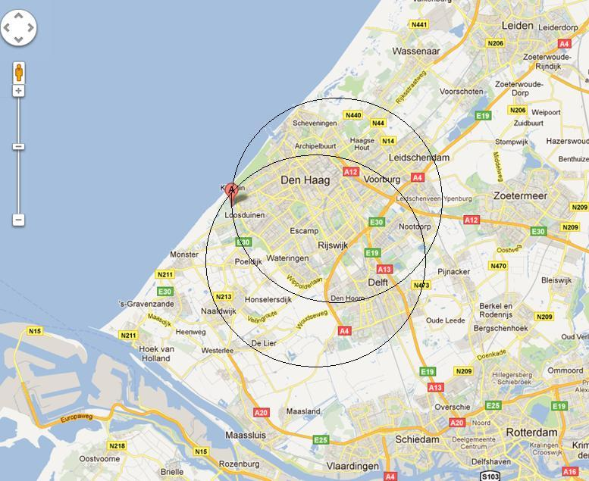
Application and Entry Process

When completing your application for bus transport, you should then return the application to Achttax. Routes and pick up times are then established. Achttax may change the routes at its sole discretion.

Availability of a place on the service will be at the sole discretion of the Taxibuscompany and will be communicated via e-mail or phone. Once a place is offered and accepted by the family, invoices will be sent home.

Availability of Places on the Service

Applying for service does not guarantee that the service will be offered or is available. The transport service is not subsidized by school fees, so certain minimum numbers are required for any given route to operate. A minimum of 6 students per bus is required. Places for students who apply will be confirmed based upon availability.

Routing

Achttax always reserves the right to change bus and pick-up time once accepted, because of newcomers / leavers during the schoolyear.

Withdrawal from Bus Service

Withdrawal of a student from the bus service must be given in writing by a minimum of 30 days. If accepted, you will receive a confirmation of terminating the Contract. Even then a prorate refund will only be made if another student from the waiting list is available to take the withdrawing student’s place.

Pick Up Procedure

Students must be on time and ready to board the bus as soon as it arrives in the morning. Drivers cannot wait for students who are running late. It is forbidden to use the horn to announce their arrival, Driver will ring the doorbell if necessary. After arrival we wait for a maximum of 3 minutes.
Under Dutch law small children are allowed to sit in a taxi bus without a booster seat. If parents prefer a booster seat they must provide one and assist with the installation of the seat on the bus.

End of School Day

For children under the age of 12, a person must be at home to receive the children at drop off time. The driver will ensure children enter the house, or in the case of an apartment, go through the first closed door. They are not allowed to leave children under the age of 12 unattended at the door. If children under the age of 12 are allowed a key this must be notified to Achttax and School in writing, so a note may be made on the bus register.

Unscheduled changes to Daily Service

If the student will not be using either pick up or return transport service on any given day, it is the responsibility of the parents to contact the Taxi company. In the mornings, this contact must be made before 7:30, in order to relay this information in time to the driver. This can be done by e-mail or through our website or leaving a message on the answering machine. If the child will not be making use of the return transport service, the Achttax and school must be contacted before 12:00. You may not find a replacement for you child if he/she cannot take the bus on a certain day.

After School Activities

When a student participates in after school activities, (e.g. sport club, music lessons, mother tongue classes, etc.) the return transport service will not be available. Accordingly, it is the parents responsibility to arrange pick up for the student. Parents are required to notify Achttax and school that the student will not be using the return transport service on that day.

School Organised Days

When schedule changes affect the entire school (e.g early release days for holidays) bus pick up and drop off times will be adjusted accordingly. However, if time or schedule changes affect only a portion of the student body (e.g. school performances, year group trips, etc.) bus pick up and drop off times will not be adjusted, and it is the parents responsibility to make alternative travel arrangements for the student. Additionally, parents are required to notify Achttax and school that the student will not be using the return transport service on that day.

If your child is in Primary and will not be using the return bus you must inform the taxi service and the Primary Office.

Withdrawal of Place

Achttax reserves the right to withdraw a student from the bus service:

- If the student is repeatedly late or keeps the bus waiting.
- If the student does not strictly follow the code of conduct detailed below.
- If parents are repeatedly absent at the scheduled drop off time.
- If invoice is not paid in full according to the above terms.
Code of Conduct

The following code of conduct must be adhered to at all times to ensure the safety of all students on the bus.

- Students must obey the drivers instruction at all times.
- The School rules, as they apply while on school grounds, also apply in the bus.
- While on the bus students must wear their seatbelts at all times.
- Students are to remain seated while the bus is in motion and must not stand until the bus comes to a complete stop.
- Food and Drink cannot be consumed on the bus.
- Students may not open a window without the driver’s permission.
- School bags must be kept on the floor, not worn or placed on seats.
- Personal belongings must be kept out of the aisles at all times.
- Students should wait well back from the roadway until the bus has come to a complete stop.
- Students must enter and exit the bus in an orderly fashion.
- Students are not allowed to open the doors of the bus, this is the responsibility of the driver.
- At the end of the School day students are to report to the driver promptly.
- Students must demonstrate respectful behavior to other riders on the bus and to the driver. Reports of misbehavior will be followed up.
- If you take or use any electronic device on the bus, then this is at your own risk. Achttax will not be responsible for any damages.
  - Bullying in the bus is not allowed. If bullying occurs, the school will be informed.

We would like you to remind your children of the 6 Golden Rules:

- Stay in your seat always.
- Keep your seatbelt on
- Use quiet voices
- Do what the driver tells you, he or she is in charge of the bus.
- Say Thank You to the driver when you get off the bus.
- Wait until you get home before eating and drinking.

Special Situations Procedure

If grievance arises regarding bus drivers or routing, parents should contact Achttax directly via email to planning@achttax.nl copying the school in any communication.

Families and riders are reminded that ISH serves as liaison with Achttax to aid in coordinating service but is not responsible for routing decisions, pick up times and financial matters.

Taxibus Company Information:

Achttax is a taxibus company that was established over 50 years ago. It has a quality label that is tested every year. This test contains the age and (cosmetic) state of the buses. Of course, the buses have an M.O.T. every year.
It also means that all drivers have an annual first-aid test and an extra education on all the developments at Achttax that year. Every driver has, besides of course a driving license, a “taxi card”. This “taxi card” is achieved by passing an exam for both theory and a practical exam for taxidrivers. It also means that his/her health is checked, and A certificate of good conduct is issued by the Ministry of Security and Justice.

Contact Information:

Main Contact
Achttax Contact Information:
e-mail: planning@achttax.nl
Telephone: 070-3839696
www.achttax.nl

ISH Contact information:
Secondary Office
e-mail: secondary@ishthehague.nl
Telephone: 070-3281450

Primary Office
e-mail: primary@ishthehaque.nl
Telephone: 070-3384567

